### Question#01

**a. Arrange into top-to-bottom**

* System
* Project
* Program
* Activity
* Phase
* Task

**b. Responsibility on PM and 4 p’s of project management**

**Responsibility of PM:**

* Tell Everyone the Truth All the Time
* Trust Your Team
* Review Everything, Test Everything
* All Software Engineers Are Created Equal
* Doing the Project Right Is Most Efficient

**4 P’s of Project Management**

* **People:** Identifying the roles people play in almost any given project is the first step to a successful project. People are the primary resource on every project, and a well-managed team can greatly increase the chances for success
* **Product:** As the name suggests, this is the deliverable of the project. The project manager should define the product scope to ensure a successful outcome, control “scope creep”; as well as technical hurdles that he or she may encounter.
* **Process:** The third P of project management is Process. Project managers and team members should have a methodology and plan that outlines their approach. Without a clearly defined process, team members will not know what to do and when to carry out project activities.
* **Project:** The fourth and final P of project management is Project. This is where the project manager’s roles and responsibilities come into play. He or she must guide team members to achieve the project’s goals and objectives.

**c. Three reason why teams are necessary**

* Working in a team create an ease while working
* It reduces the workload if several persons work on a project
* It provides different and sometimes beneficial perspectives to do a work.

**d. Common Project Planning Problems**

* Disregard for the planning process
* Scope creep
* Exceed the budget
* Lack of communication
* Shifting deadlines
* Lack of accountability
* Decentralized information

**e. Mitigation Plan activity with respect to any project**

* **Alter the project plan***.* The project schedule can be adjusted to help reduce the risk. Riskier tasks can be moved earlier in the project or given more time. **e.g.** there is a module included in the project which needs a more time than the said time. Then the team will alter the project plan.
* **Add additional tasks***.* There are certain actions that can be added to the schedule to help avoid risks. e.g. there is a project which is providing confidentiality of data and it needs some other modules to be completed then some additional tasks will be added to the project.
* **Plan for risks***.* For risks with a high impact that do not need specific tasks or project plan changes, the project manager should have the team spend a few minutes identifying the steps that should be taken in case the risk does occur.

### Question#02

Define Myers-Briggs type Indicator and how it helps to understand the employee personality and their expected performance?

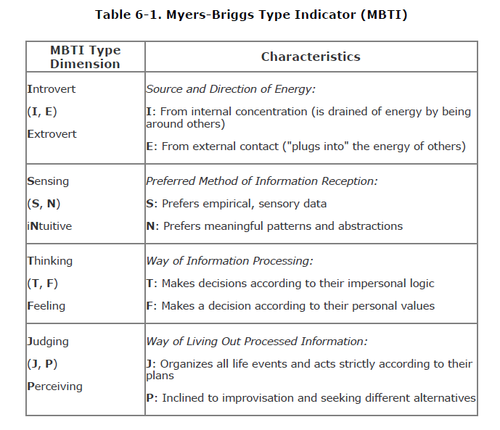If a project manager knows about theses individual personality types, it will help them in team formation as well as it helps him to decide which type of worker should be placed with which type of worker.

Also, he can easily determine the techniques which will he use to get things done without going offboard.

### Question#03

Define Wideband Delphi Estimation Technique, its process and how it helps to estimate a project.

**Wideband Delphi Estimation Technique:**

The Wideband Delphiestimation method was developed in the 1940s at the Rand Corporation as a forecasting tool.

The Wideband Delphi estimation process is especially useful to a project manager because it produces several important elements of the project plan.

Wideband Delphi works because it requires the entire team to correct one another in a way that helps avoid errors and poor estimation.

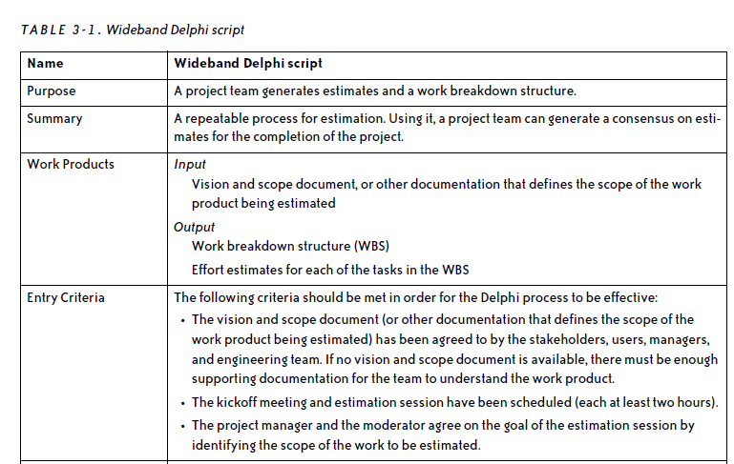**Process:**

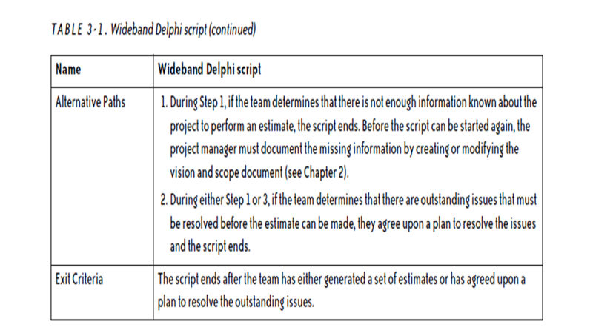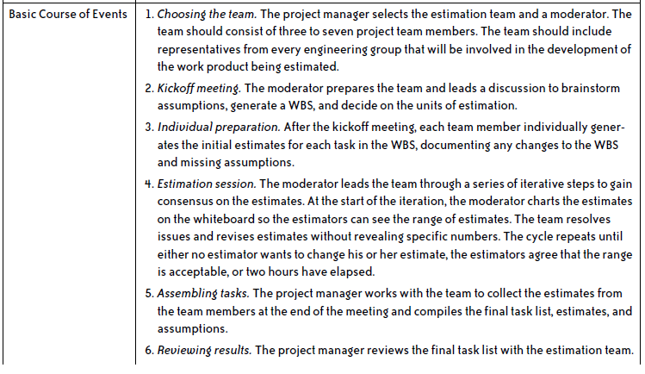

It helps in estimation as it uses WBS as an input and it allows all the team members to sit together as discuss each estimate in detail and check any issue as early as possible.